Worksheet 1.2

Student Name: Rydem UID: 25MCI10275
Branch: MCA (AI & ML) Section/Group: MAM-1 (A)
Semester: I Date of Performance: 07/09/25
Subject Name: PL/SQL Subject Code: 25CAP-602

1. Aim/Overview of the practical:
Experiment-1:
To implement and understand horizontal fragmentation of relations in a distributed database for efficient query processing and data distribution.
2. Question:
Horizontal Fragmentation and Relational Algebra Optimization in a Distributed Database Environment
- Given a relation employee in the following figure:

- Let p1: TITLE< “Programmer” and p2: Title> “Programmer” be two simple predicates, assume that character strings have an order among them, based on the alphabetical order.
- Perform a horizontal fragmentation of relation EMP with respect to {p1, p2}.
- Explain why the resulting fragmentation (EMP1, EMP2) does not fulfill the correctness rules of fragmentation.
- Modify the predicates p1 and p2 so that they partition EMP obeying the correctness rules of fragmentation. To do this, modify the predicates, compose all minterm predicates and deduce the corresponding implications, and then perform a horizontal fragmentation of EMP based on these minterm predicates. Finally, show that the result has completeness, reconstruction and disjointness properties.

3. CODING:
- Creation of Table:
CREATE TABLE EMPLOYEE (
ENO VARCHAR(5) PRIMARY KEY,
ENAME VARCHAR(50),
TITLE VARCHAR(50),
);

- Insertion Of Records:
INSERT INTO EMPLOYEE VALUES
(‘E1’, ‘J. Doe’, ‘Elect.Eng’);
(‘E2’, ‘M. Smith’, ‘System Anal.’);
(‘E3’, ‘A. Lee’, ‘Mech Eng.’);
(‘E4’, ‘J. Miller’, ‘Programmer’);
(‘E5’, ‘B. Casey’, ‘System Anal.’);
(‘E6’, ‘L. Chu’, ‘Elect.Eng.’);
(‘E7’, ‘R. Davis’, ‘Mech Eng.’);
(‘E8’, ‘J. Jones’, ‘System Anal.’);

- Fragmentation in Table:
CREATE TABLE EMP1 AS SELECT * FROM EMPLOYEE WHERE 1=0;
CREATE TABLE EMP2 AS SELECT * FROM EMPLOYEE WHERE 1=0;

- Insertion into these fragmented tables:
Fragmentation 1:
INSERT INTO EMP1
SELECT * FROM EMPLOYEE
WHERE TITLE<'Programmer';

Fragmentation 2:
INSERT INTO EMP2
SELECT * FROM EMPLOYEE
WHERE TITLE>'Programmer';

- Correctness:
The resulting fragmentation do not fulfill the correctness rules of fragmentation as the TITLE= ‘Programmer’ is missing from both the tables.
To fix this we need to create one more table EMP3 which contains the title programmer.
Fragmentation 3:
CREATE TABLE EMP3 AS SELECT * FROM EMPLOYEE WHERE 1=0;
INSERT INTO EMP3
SELECT * FROM EMPLOYEE
WHERE TITLE='Programmer';

4. OUTPUT:
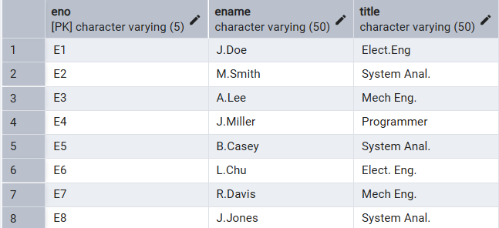
- Employee Table:

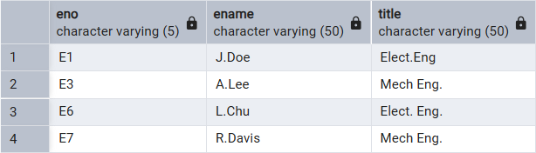
- Emp1 Table:

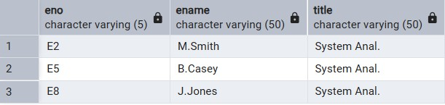
- Emp2 Table:

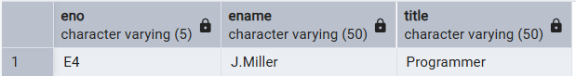
- Emp3 Table:

5. Learning Outcome:
- Creating a table.
- Insertion operation.
- Horizontal Fragmentation.
- Correctness rules of fragmentation.

